

Software Requirements Specification

for

LAFCHEMCO System, Release 1.0

**Version 1.0**

**Prepared by Nguyễn Đức Phương, Vũ Văn Trọng, Bùi Sỹ Thái Hoàng, Nguyễn Hữu Cường**

**July 14th, 2024**

– Hanoi, July 2024 –

# 

# Record of Changes

| **Version** | **Date** | **A*, M, D** | **In charge** | **Change Description** |
| --- | --- | --- | --- | --- |
| V1.0 | 01/06/2024 | A | trongvvhe172080 | Initialize the document (I, II) |
| V1.0 | 10/07/2024 | M | phuongndhe186453 | User Requirements (II) |
| V1.0 | 10/07/2024 | A | phuongndhe186453 | User Management (III.2)  Equipment Management (III.3) |
| V1.0 | 11/07/2024 | A | trongvvhe172080 | Inventory Management (III.4) |
| V1.0 | 12/07/2024 | A | hoangbsthe186345 | Maintenance Plan Management (III.5) |
| V1.0 | 13/07/2024 | A | cuongnhhe186494 | Maintenance Operation Management (III.6) |
| V1.0 | 14/07/2024 | M | phuongndhe186453 | Complete the document (Non-Functional Requirements, IV; Accounting Management, III.7) |

*A - Added M - Modified D - Deleted

# Contents

Record of Changes 2

Contents 3

I. Overall Description 5

1. Product Overview 5

2. Business Rules 5

II. User Requirements 9

1. System Actors 9

2. Use Case Diagram 10

III. Functional Requirements 10

1. System Functional Overview 10

2. User Management 12

2.1. Add User 12

2.2. View User Details 14

2.3. Deactivate User 17

3. Equipment Management 19

3.1. Add Equipment 19

3.2. View Equipment Details 20

3.3. Delete Equipment 21

3.4. Assign Equipment 23

3.5. Request Maintenance 25

3.6. Report Equipment Issues 26

4. Inventory Management 27

4.1. Add Material Report 27

4.2. View Material Report Details 30

4.3. Delete Material Report 32

5. Maintenance Plan Management 34

5.1. Add Maintenance Plan 34

5.2. View Maintenance Plan Details 36

5.3. Delete Maintenance Plan 38

6. Maintenance Operation Management 40

6.1. Add Maintenance Work 40

6.2. View Maintenance Work Details 42

6.3. Delete Maintenance Work 44

7. Accounting Management 46

7.1 Approve Disbursement Request 46

7.2 View Disbursement Request Details 48

IV. Non-Functional Requirements 49

1. External Interfaces 49

1.1. User Interfaces 49

1.2. Software Interfaces 49

1.3. Hardware Interfaces 49

1.4. Communications Interfaces 49

2. Quality Attributes 50

2.1. Usability Requirements 50

2.2. Performance Requirements 50

2.3. Security Requirements 50

2.4. Safety Requirements 50

2.5. Availability Requirements 50

2.6. Robustness Requirements 51

# I. Overall Description

## 1. Product Overview

The LAFCHEMCO System is a new software system that replaces manual processes for managing equipment maintenance and repair activities within the company. The context diagram in Figure 1 illustrates the external entities and system interfaces for the initial release. Future releases will expand connectivity to integrate with inventory management systems and other relevant interfaces.

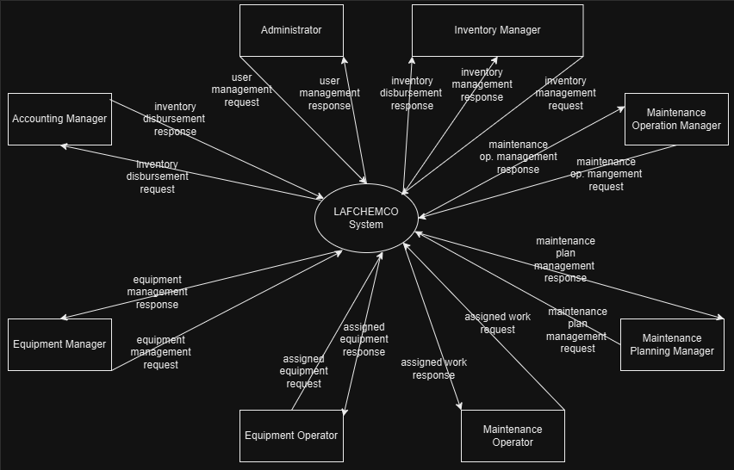

**Figure 1. Context Diagram of the LAFCHEMCO System**

The software application will enable comprehensive management of equipment and maintenance operations across the company. It includes functionalities such as:

* Creating, updating, and viewing equipment details throughout their lifecycle.
* Assigning equipment to operators and tracking their usage.
* Managing inventory related to maintenance operations and integrating with warehouse management systems.
* Planning and scheduling maintenance tasks at various intervals (yearly, quarterly, monthly, weekly).
* Monitoring and reporting on maintenance activities, including work orders, personnel assignments, and material usage.

This software aims to streamline operations, reduce costs associated with equipment management and maintenance, and minimize operational downtime due to equipment failures.

## 2. Business Rules

| ID | Description | Type of Rule | Static or Dynamic |
| --- | --- | --- | --- |
| BR-1 | Each username must be unique within the system. | Fact | Static |
| BR-2 | The email address must be in a valid email format. | Constraint | Static |
| BR-3 | All required fields must be filled out. | Constraint | Dynamic |
| BR-4 | Passwords must be encrypted using BCrypt. | Constraint | Static |
| BR-5 | Each new user must be assigned at least one role. | Constraint | Dynamic |
| BR-6 | Newly added user accounts must be activated by the Administrator before use. | Constraint | Dynamic |
| BR-7 | Only authenticated users can view user details. | Fact | Dynamic |
| BR-8 | Only Administrators can modify user details. | Fact | Dynamic |
| BR-9 | All modifications must meet the validation rules for user data (e.g., valid email format, unique username). | Constraint | Dynamic |
| BR-10 | Changes to user details must be saved and reflected in the system immediately. | Fact | Dynamic |
| BR-11 | Only Administrators can activate or deactivate user accounts. | Fact | Dynamic |
| BR-12 | The system must log all changes for audit purposes. | Action Enablers | Static |
| BR-13 | Deactivated users cannot log in or access the system. | Fact | Dynamic |
| BR-14 | Re-activation must restore the user's previous access rights and permissions. | Fact | Static |
| BR-15 | Only authenticated Administrators or Equipment Managers can add new equipment. | Fact | Static |
| BR-16 | Each equipment must have a unique equipment ID. | Constraint | Static |
| BR-17 | All required fields must be filled out with valid data. | Constraint | Dynamic |
| BR-18 | Only authenticated users can view equipment details. | Fact | Static |
| BR-19 | Equipment Operators can only view equipment assigned to them. | Fact | Static |
| BR-20 | Only Administrators and Equipment Managers can modify equipment details. | Fact | Static |
| BR-21 | All modifications must meet the validation rules for equipment data (e.g., valid serial number, unique equipment ID). | Constraint | Dynamic |
| BR-22 | Only authenticated Administrators or Equipment Managers can delete equipment. | Fact | Static |
| BR-23 | Deletion of equipment must be confirmed by the Administrator or Equipment Manager to proceed. | Action Enabler | Dynamic |
| BR-24 | Only authenticated Administrators or Equipment Managers can assign equipment. | Fact | Static |
| BR-25 | Equipment must be available and suitable for assignment to the selected Equipment Operator. | Fact | Static |
| BR-26 | Only authenticated Administrators or Equipment Managers can request maintenance. | Fact | Static |
| BR-27 | Maintenance requests must be approved by the Maintenance Planning Manager before proceeding. | Action Enabler | Dynamic |
| BR-28 | Only authenticated Equipment Operators can report equipment issues. | Fact | Static |
| BR-29 | Equipment issues must be reported to an Equipment Manager for resolution. | Action Enabler | Static |
| BR-30 | Only authenticated Administrators or Inventory Managers can create material reports. | Fact | Static |
| BR-31 | Material reports must include all required information (type, quantity, source/destination, reason). | Constraint | Dynamic |
| BR-32 | Only authenticated Administrators or Inventory Managers can view or update material reports. | Fact | Static |
| BR-33 | Material reports must be retrieved accurately from the system. | Fact | Static |
| BR-34 | Only authenticated Administrators or Inventory Managers can delete material reports. | Fact | Static |
| BR-35 | Material reports must be retrieved accurately from the system before deletion. | Fact | Static |
| BR-36 | All deletions of material reports must be confirmed by the user. | Action Enabler | Dynamic |
| BR-37 | Only authenticated Administrators or Maintenance Planning Managers can create maintenance plans. | Fact | Static |
| BR-38 | Maintenance plans must include all required details and be assigned to a Maintenance Operation Manager. | Constraint | Static |
| BR-39 | Maintenance requests from Equipment Managers must be reviewed and either approved or rejected by the Maintenance Planning Manager. | Action Enabler | Dynamic |
| BR-40 | Only authenticated Administrators or Maintenance Planning Managers can view or update maintenance plans. | Fact | Static |
| BR-41 | Maintenance plans must be retrieved accurately from the system. | Fact | Static |
| BR-42 | All related personnel must be informed of any successful updates. | Action Enabler | Dynamic |
| BR-43 | Only authenticated Administrators or Maintenance Planning Managers can delete maintenance plans. | Fact | Static |
| BR-44 | All deletions of maintenance plans must be confirmed by the user. | Action Enabler | Dynamic |
| BR-45 | Only authenticated Administrators or Maintenance Operation Managers can create maintenance work plans. | Fact | Static |
| BR-46 | Maintenance work plans must be based on existing maintenance plans | Constraint | Static |
| BR-47 | All tasks within the maintenance work plan must be assigned to appropriate Maintenance Operators. | Fact | Dynamic |
| BR-48 | Only authenticated Administrators or Maintenance Operation Managers can view or update maintenance work details. | Fact | Static |
| BR-49 | Maintenance work details must be retrieved accurately from the system. | Fact | Static |
| BR-50 | Only authenticated Administrators or Maintenance Operation Managers can delete task assignments from maintenance work plans. | Fact | Static |
| BR-51 | Task assignments must be retrieved accurately from the system before deletion. | Fact | Static |
| BR-52 | All deletions of task assignments from maintenance work plans must be confirmed by the user. | Action Enabler | Dynamic |
| BR-53 | Only authorized Administrators or Accounting Managers can approve or reject disbursement requests. | Fact | Static |
| BR-54 | A reason must be provided for any rejection of a disbursement request. | Constraint | Dynamic |
| BR-55 | The system must ensure data integrity and prevent any concurrent modifications to the same disbursement request. | Constraint | Dynamic |
| BR-56 | Only authorized Administrators or Accounting Managers can view disbursement request details. | Fact | Static |

# II. User Requirements

## 1. System Actors

| Actor | Description |
| --- | --- |
| Equipment  Manager | The Equipment Manager oversees the management and maintenance of equipment across various departments. They are responsible for creating, updating, and assigning equipment to operators for operational use. |
| Equipment  Operator | Equipment Operators are responsible for operating assigned equipment and reporting any issues encountered during operation. |
| Inventory  Manager | The Inventory Manager oversees the inventory related to maintenance operations, ensuring timely availability of materials and parts for maintenance and repair tasks. |
| Maintenance  Operation  Manager | The Maintenance Operation Manager coordinates and supervises maintenance activities, ensuring they are carried out according to schedules and standards. |
| Maintenance  Operator | Maintenance Operators perform maintenance and repair tasks on assigned equipment as instructed by the Maintenance Operation Manager. |
| Maintenance  Planning  Manager | The Maintenance Planning Manager plans and schedules maintenance tasks based on equipment needs and operational requirements. |
| Accounting  Manager | The Accounting Manager is responsible for controlling the company's cash flow for the purchase and disbursement of materials for the maintenance and repair of equipment. |
| Administrator | The Administrator has the highest privilege of the system. He/She can manage all the business actions and users. |

## 2. Use Case Diagram

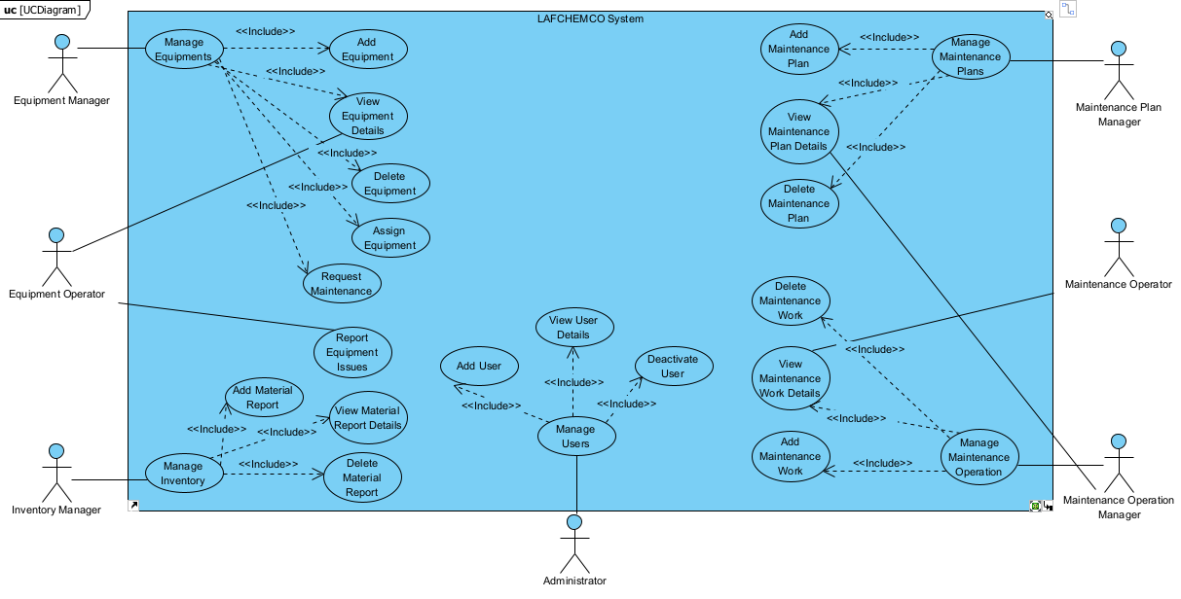

**Figure 2. Use Case Diagram for the LAFCHEMCO System**

# III. Functional Requirements

## 1. System Functional Overview

The Maintenance Management System (LAFCHEMCO System) facilitates efficient management and monitoring of equipment maintenance and repair processes across the company. It integrates various functionalities to streamline operations, enhance productivity, and ensure equipment reliability. Key features include:

1. **User Management**:
   * Administrators can manage user accounts, roles, and permissions.
   * Equipment Managers oversee equipment assignments and maintenance activities.
   * Maintenance Planning Managers coordinate maintenance schedules and allocate tasks.
2. **Equipment Management**:
   * Users can view detailed information about equipment, including specifications, maintenance history, and current status.
   * Equipment can be added, updated, or removed from the system by authorized personnel.
   * Maintenance requests can be generated directly from equipment records.
3. **Maintenance Planning and Execution**:
   * Maintenance Planning Managers create and manage maintenance plans based on predefined schedules (e.g., annually, quarterly).
   * Maintenance Operation Managers assign specific maintenance tasks to Maintenance Operators based on workload and skill sets.
4. **Accounting Management:**
   * Monitor and control the company’s cash flow for purchasing and disbursing funds for maintenance and repair of equipment.
   * Ensure accurate and timely processing of fund disbursement requests for procurement of maintenance materials.
   * Generate financial reports related to maintenance costs and expenditures.
   * Provide insights and analysis on financial performance of maintenance activities to support decision-making.
5. **Reporting and Analytics**:
   * The system generates reports on equipment performance, maintenance activities, and resource utilization.
   * Analytics tools provide insights into trends, efficiency metrics, and compliance with maintenance schedules.
6. **Integration and Interfaces**:
   * Interfaces with external systems such as inventory management for parts availability and procurement.
   * Communication interfaces for notifications and alerts related to maintenance tasks, equipment status changes, and scheduling updates.
7. **Security and Access Control**:
   * Role-based access controls ensure that users only have access to functionalities relevant to their roles.
   * Encryption and secure protocols protect sensitive data and transactions within the system.
8. **Usability and Performance**:
   * User interfaces are designed to be intuitive, supporting efficient navigation and task execution.
   * Performance metrics ensure that system response times meet operational requirements, even during peak usage periods.
9. **Safety and Compliance**:
   * Safety protocols associated with maintenance tasks are integrated into the system, ensuring adherence to regulatory requirements and best practices.
   * Compliance with organizational policies and industry standards for equipment maintenance and safety.

The LAFCHEMCO SYSTEM aims to optimize maintenance workflows, reduce downtime, enhance equipment reliability, and improve overall operational efficiency within the company.

## 2. User Management

### 2.1. Add User

#### a. Description

#### b. Use Case Specification

| Name | Add User |
| --- | --- |
| Created By | phuongndhe186453 |
| Created At | 10/07/2024 |
| Primary Actor | Administrator |
| Secondary Actor | None |
| Description | This use case allows the Administrator to add a new user to the system. |
| Precondition | PRE-1 The Administrator account is required. |
| Postcondition | POST-1 New user is saved into the system. |
| Normal Flow | 1.0 Add User  1. The Administrator requests to add a new user.  2. The system shows the form for the Administrator to fill information.  3. The Administrator fills all required fields.  4. The system validates the input fields. (see A1.1)  5. The system saves information into the system and shows a confirmation dialog to the Administrator. (see E1.1) |
| Alternative Flow | A1.1 Invalid Fields  1. The system shows description about invalid fields.  2. The Administrator either aborts the process (see 3a) or continue (see 3b).  3a. System terminates the use case without saving the new user.  3b.1. The Administrator modifies information to correct them.  3b.2. The system attempts saving the new user again. |
| Exception | E1.1 System Error  1. The system shows an error notification to the Administrator.  2. The system aborts the process without saving the new user.  E1.2 Database Unavailable  1. The system detects that the user database is unavailable.  2. The system shows a notification to the Administrator about the unavailability.  3. The system aborts the process without saving the new user.  E1.3 Duplicate Username  1. The system detects that the username already exists in the system.  2. The system shows a notification to the Administrator about the duplicate username.  3. The Administrator must provide a unique username to proceed. |
| Business Rule | BR-1, BR-2, BR-3, BR-4, BR-5, BR-6 |

#### c. Wireframe Screen

### 2.2. View User Details

#### a. Wireframe Screen:

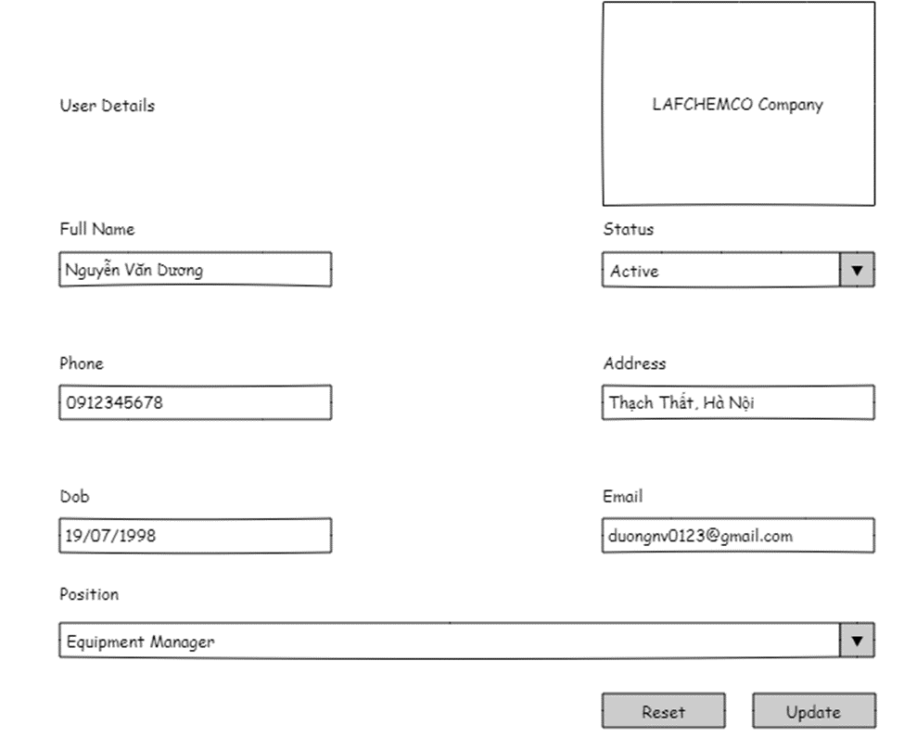

User Details Screen of Administrator

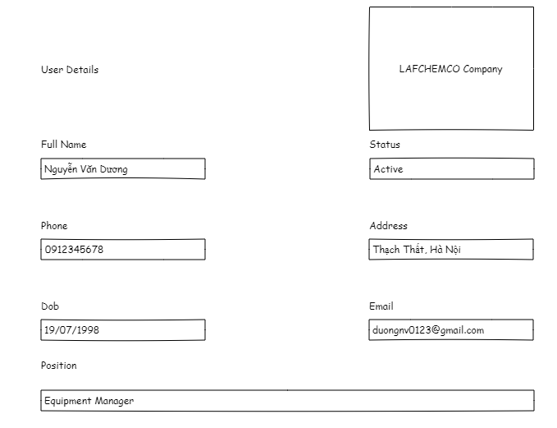

User Details screen of non-Administrator

#### b. Use Case Specification:

| Name | View User Details |
| --- | --- |
| Created By | phuongndhe186453 |
| Created At | 10/07/2024 |
| Primary Actor | Authenticated User |
| Secondary Actor | None |
| Description | This use case allows the authenticated users to modify (if they are the Administrator) and view a user's detailed information. |
| Precondition | PRE-1 The user must be authenticated. |
| Postcondition | POST-1: User details are displayed to the authenticated user.  POST-2: If modified by the Administrator, the updated user details in the system are saved. |
| Normal Flow | 2.0 View User Details  1. The authenticated user requests to view a user's details.  2. The system retrieves the user's details from the system.  3. The system displays the user's details to the authenticated user. (see A2.1) |
| Alternative Flow | A2.1 Modify User Details (Administrator)  1. The Administrator selects the option to modify the user's details.  2. The system shows the form for the Administrator to edit the user information.  3. The Administrator modifies the necessary fields.  4. The system validates the input fields. (see A2.2)  5. The system saves the updated information into the system and shows a confirmation dialog to the Administrator. (see E2.1)  A2.2 Invalid Fields (Modification)  1. The system shows a description of the invalid fields.  2. The Administrator either aborts the process (see 3a) or continues (see 3b).  3a. The system terminates the use case without saving the modifications.  3b.1. The Administrator modifies the information to correct them.  3b.2. The system attempts saving the updated user details again. |
| Exception | E2.1 System Error  1. The system shows an error notification to the authenticated user.  2. The system aborts the process without displaying the user details.  E2.2 Database Unavailable  1. The system detects that the user database is unavailable.  2. The system shows a notification to the authenticated user about the unavailability.  3. The system aborts the process without displaying the user details.  E2.3 Unauthorized Access Attempt  1. The system detects that the user attempting to view or modify details is not authorized.  2. The system logs the unauthorized access attempt.  3. The system shows an error notification and aborts the process without displaying or modifying the user details. |
| Business Rule | BR-7, BR-8, BR-9, BR-10 |

### 2.3. Deactivate User

#### a. Wireframe Screen

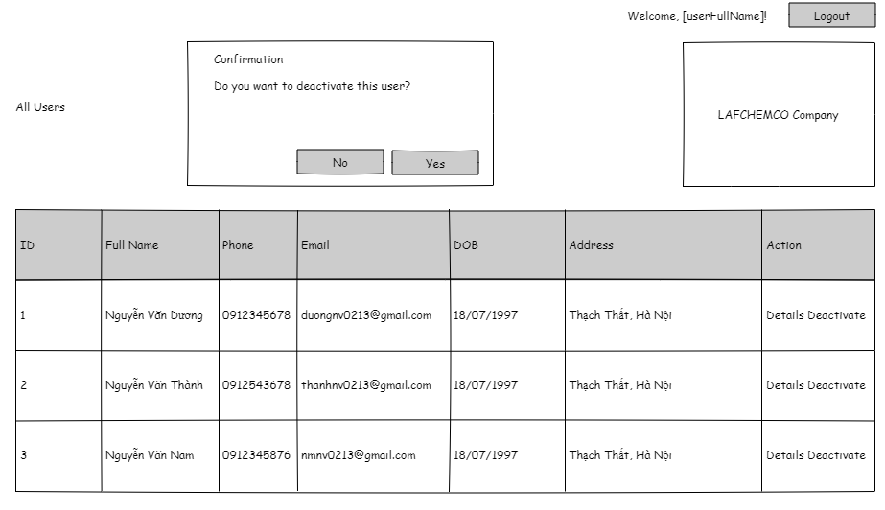

Deactivate User screen after clicking “Deactivate” (if that user status is currently “Active”)

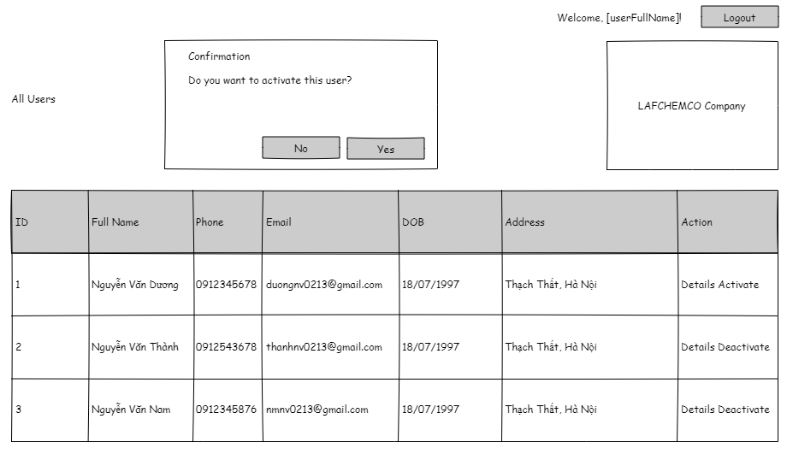

Deactivate User screen after clicking “Activate” (if that user status is currently “Inactive”)

#### b. Use Case Specification

| Name | Deactivate User |
| --- | --- |
| Created By | phuongndhe186453 |
| Created At | 10/07/2024 |
| Primary Actor | Administrator |
| Secondary Actor | None |
| Description | This use case allows the Administrator to activate or deactivate a user. |
| Precondition | PRE-1 The Administrator account is required. |
| Postcondition | POST-1: The user's status is updated to deactivated or re-activated in the system. |
| Normal Flow | 3.0 Deactivate User  1. The Administrator requests to deactivate a user. (see A3.1)  2. The system retrieves the user's current status from the system  3. The system displays the user's current status to the Administrator.  4. The Administrator confirms the deactivation.  5. The system updates the user's status to deactivated in the system and shows a confirmation dialog to the Administrator. (see E3.1) |
| Alternative Flow | A3.1 Reactivate User  1. The Administrator requests to re-activate a user.  2. The system retrieves the user's current status from the system.  3. The system displays the user's current status to the Administrator.  4. The Administrator confirms the re-activation.  5. The system updates the user's status to active in the system and shows a confirmation dialog to the Administrator. (see E3.1) |
| Exception | E3.1 System Error  1. The system shows an error notification to the Administrator.  2. The system aborts the process without updating the user's status.  E3.2 Database Unavailable  1. The system detects that the user database is unavailable.  2. The system shows a notification to the Administrator about the unavailability.  3. The system aborts the process without updating the user's status.  E3.3 Unauthorized Access Attempt  1. The system detects that the user attempting to deactivate or activate an account is not an Administrator.  2. The system logs the unauthorized access attempt.  3. The system shows an error notification and aborts the process without making any changes to the user's status. |
| Business Rule | BR-11, BR-12, BR-13, BR-14 |

## 3. Equipment Management

### 3.1. Add Equipment

#### a. Wireframe Screen:

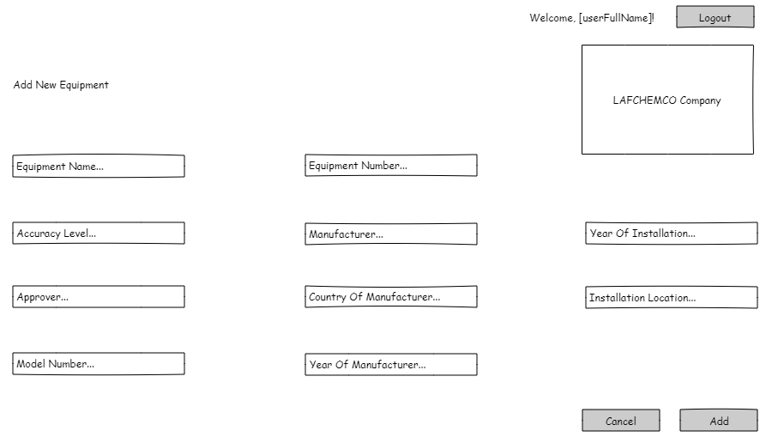

#### b. Use Case Specification:

| Name | Add Equipment |
| --- | --- |
| Created By | phuongndhe186453 |
| Created At | 10/07/2024 |
| Primary Actor | Administrator, Equipment Manager |
| Secondary Actor | None |
| Description | This use case allows the Administrator or Equipment Manager to add new equipment to the system. |
| Precondition | PRE-1: The user must be an authenticated Administrator or Equipment Manager. |
| Postcondition | POST-1 New equipment is saved into the system. |
| Normal Flow | 4.0 Add Equipment  1. The Administrator or Equipment Manager requests to add new equipment.  2. The system shows the form for the user to fill in equipment information.  3. The user fills all required fields.  4. The system validates the input fields. (see A4.1)  5. The system saves the equipment information into the system and shows a confirmation dialog to the user. (see E4.1) |
| Alternative Flow | A4.1 Invalid Fields  1. The system shows a description of the invalid fields.  2. The user either aborts the process (see 3a) or continues (see 3b).  3a. The system terminates the use case without saving the new equipment.  3b.1. The user modifies the information to correct them.  3b.2. The system attempts saving the new equipment again. |
| Exception | E4.1 System Error  1. The system shows an error notification to the user.  2. The system aborts the process without saving the new equipment.  E4.2 Database Unavailable  1. The system detects that the equipment database is unavailable.  2. The system shows a notification to the user about the unavailability.  3. The system aborts the process without saving the new equipment.  E4.3 Duplicate Equipment ID  1. The system detects that the equipment ID already exists in the system.  2. The system shows a notification to the user about the duplicate equipment ID.  3. The user must provide a unique equipment ID to proceed. |
| Business Rule | BR-12, BR-15, BR-16, BR-17 |

### 3.2. View Equipment Details

#### a. Wireframe Screen:

#### b. Use Case Specification:

| Name | View Equipment Details |
| --- | --- |
| Created By | phuongndhe186453 |
| Created At | 10/07/2024 |
| Primary Actor | Administrator, Equipment Manager, Equipment Operator |
| Secondary Actor | None |
| Description | This use case allows authenticated users to modify (if they are either Administrator or Equipment Manager) and view equipment detailed information (if Equipment Operator, he/she can only see equipment assigned to them; the rest will be able to choose any equipment to view). |
| Precondition | PRE-1 The user must be authenticated. |
| Postcondition | POST-1: Equipment details are displayed to the authenticated user.  POST-2: If modified by the Administrator or Equipment Manager, the updated equipment details are saved in the system. |
| Normal Flow | 5.0 View Equipment Details  1. The authenticated user requests to view equipment details.  2. The system retrieves the equipment details from the system.  3. The system displays the equipment details to the authenticated user. |
| Alternative Flow | A5.1 Modify Equipment Details (Administrator or Equipment Manager)  1. The Administrator or Equipment Manager selects the option to modify the equipment details.  2. The system shows the form for the user to edit the equipment information.  3. The user modifies the necessary fields.  4. The system validates the input fields. (see A5.2)  5. The system saves the updated information into the system and shows a confirmation dialog to the user. (see E5.1)  A5.2 Invalid Fields (Modification)  1. The system shows a description of the invalid fields.  2. The user either aborts the process (see 3a) or continues (see 3b).  3a. The system terminates the use case without saving the modifications.  3b.1. The user modifies the information to correct them.  3b.2. The system attempts saving the updated equipment details again. |
| Exception | E5.1 System Error  1. The system shows an error notification to the user.  2. The system aborts the process without displaying or saving the equipment details.  E5.2 Database Unavailable  1. The system detects that the equipment database is unavailable.  2. The system shows a notification to the user about the unavailability.  3. The system aborts the process without displaying or saving the equipment details.  E5.3 Unauthorized Access Attempt  1. The system detects that the user attempting to view or modify details is not authorized.  2. The system logs the unauthorized access attempt.  3. The system shows an error notification and aborts the process without displaying or modifying the equipment details. |
| Business Rule | BR-12, BR-18, BR-19, BR-20, BR-21 |

### 3.3. Delete Equipment

#### a. Wireframe Screen:

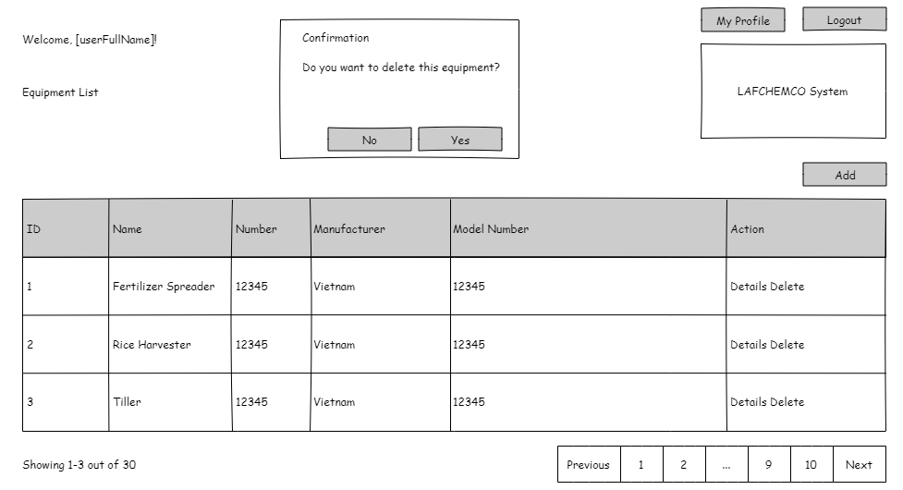

Delete Equipment screen (the pop-up opens after clicking “Delete”)

#### b. Use Case Specification:

| Name | Delete Equipment |
| --- | --- |
| Created By | phuongndhe186453 |
| Created At | 10/07/2024 |
| Primary Actor | Administrator, Equipment Manager |
| Secondary Actor | None |
| Description | This use case allows authenticated users to remove equipment from the system. |
| Precondition | PRE-1: The user must be an authenticated Administrator or Equipment Manager. |
| Postcondition | POST-1 The equipment is removed from the system. |
| Normal Flow | 6.0 Delete Equipment  1. The Administrator or Equipment Manager requests to delete equipment.  2. The system retrieves the equipment details to confirm deletion.  3. The system displays the equipment details to the Administrator or Equipment Manager.  4. The Administrator or Equipment Manager confirms the deletion.  5. The system removes the equipment from the system and shows a confirmation dialog. |
| Alternative Flow | A6.1 Cancel Deletion  1. The Administrator or Equipment Manager decides to cancel the deletion.  2. The system aborts the deletion process and returns to the equipment details view. |
| Exception | E6.1 System Error  1. The system shows an error notification to the user.  2. The system aborts the deletion process without removing the equipment.  E6.2 Database Unavailable  1. The system detects that the equipment database is unavailable.  2. The system shows a notification to the user about the unavailability.  3. The system aborts the deletion process without removing the equipment.  E6.3 Unauthorized Access Attempt  1. The system detects that the user attempting to delete equipment is not authorized.  2. The system logs the unauthorized access attempt.  3. The system shows an error notification and aborts the deletion process without removing the equipment. |
| Business Rule | BR-12, BR-22, BR-23 |

### 3.4. Assign Equipment

#### a. Wireframe Screen:

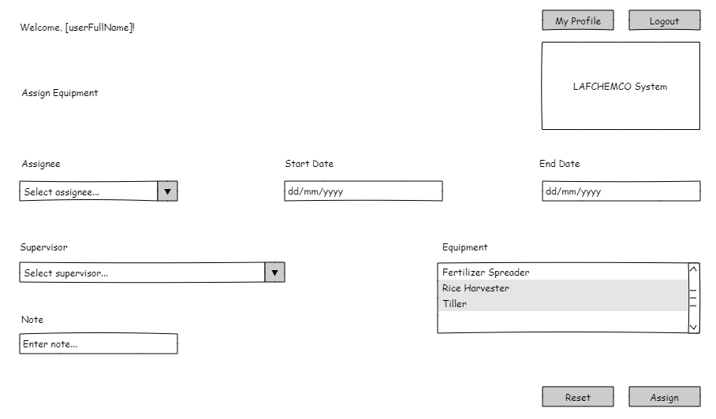

#### b. Use Case Specification:

| Name | Assign Equipment |
| --- | --- |
| Created By | phuongndhe186453 |
| Created At | 10/07/2024 |
| Primary Actor | Administrator, Equipment Manager |
| Secondary Actor | Equipment Operator |
| Description | This use case allows the Administrator or Equipment Manager to assign certain equipment to an Equipment Operator. |
| Precondition | PRE-1: The user must be an authenticated Administrator or Equipment Manager.  PRE-2: Equipment Operator must be available in the system. |
| Postcondition | POST-1 The selected equipment is assigned to the Equipment Operator. |
| Normal Flow | 7.0 Assign Equipment  1. The Administrator or Equipment Manager requests to assign equipment to an Equipment Operator.  2. The system retrieves the list of available equipment and Equipment Operators.  3. The Administrator or Equipment Manager selects the equipment and the Equipment Operator.  4. The system validates the assignment criteria (see A7.1).  5. The system updates the assignment in the system and shows a confirmation dialog. |
| Alternative Flow | A7.1 Invalid Assignment Criteria  1. The system identifies that the selected equipment cannot be assigned to the selected Equipment Operator due to constraints (e.g., equipment availability, permissions). (see 2a and 2b)  2a.1 The Administrator or Equipment Manager is notified about the invalid assignment criteria.  2a.2. The Administrator or Equipment Manager adjusts the assignment criteria or selects different equipment or Operator.  2b.1. The Administrator or Equipment Manager aborts the process.  2b.2. The system terminates the use case without assigning the equipment. |
| Exception | E7.1 System Error  1. The system shows an error notification to the user.  2. The system aborts the assignment process without making any changes.  E7.2 Database Unavailable  1. The system detects that the equipment database is unavailable.  2. The system shows a notification to the user about the unavailability.  3. The system aborts the assignment process without making any changes.  E7.3 Unauthorized Access Attempt  1. The system detects that the user attempting to assign equipment is not authorized.  2. The system logs the unauthorized access attempt.  3. The system shows an error notification and aborts the assignment process without making any changes. |
| Business Rule | BR-12, BR-24, BR-25 |

### 3.5. Request Maintenance

#### a. Wireframe Screen:

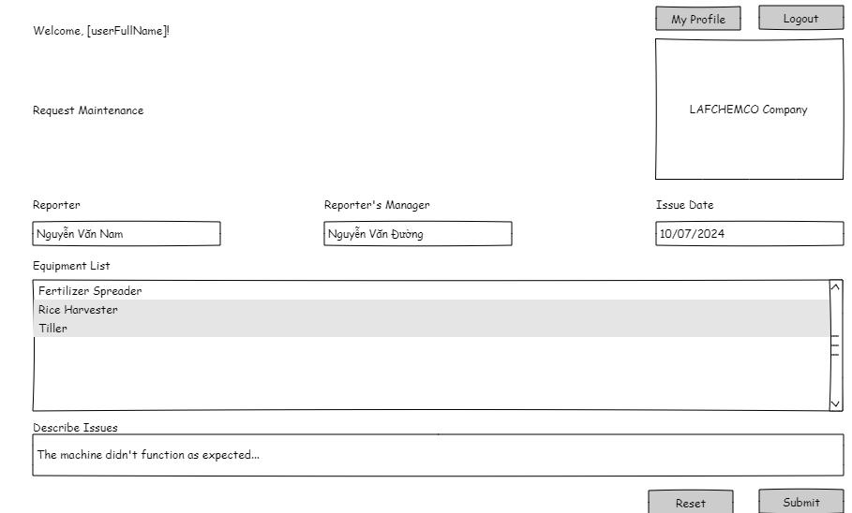

#### b. Use Case Specification:

| Name | Request Maintenance |
| --- | --- |
| Created By | phuongndhe186453 |
| Created At | 10/07/2024 |
| Primary Actor | Administrator, Equipment Manager |
| Secondary Actor | Maintenance Planning Manager |
| Description | This use case allows the Administrator or Equipment Manager to send a maintenance request to the Maintenance Planning Manager for approval. |
| Precondition | PRE-1: The user must be an authenticated Administrator or Equipment Manager.  PRE-2: Maintenance Planning Manager must be available in the system. |
| Postcondition | POST-1 The maintenance request is sent to the Maintenance Planning Manager for approval. |
| Normal Flow | 8.0 Request Maintenance  1. The Administrator or Equipment Manager requests maintenance for specific equipment.  2. The system retrieves the list of available Maintenance Planning Managers and maintenance plans.  3. The Administrator or Equipment Manager selects the equipment requiring maintenance and the Maintenance Planning Manager.  4. The system validates the request criteria (see A8.1).  5. The system sends the maintenance request to the Maintenance Planning Manager and shows a confirmation dialog. |
| Alternative Flow | A8.1 Issue Reports from Equipment Operator  1. The system automatically generates a maintenance request based on issue reports submitted by Equipment Operators.  2. The system notifies the Administrator or Equipment Manager about the generated request and provides options to review or confirm.  3. If confirmed:  3.1 The Administrator or Equipment Manager selects a Maintenance Planning Manager as the recipient of the request.  3.2 The system sends the maintenance request to the selected Maintenance Planning Manager and shows a confirmation dialog. |
| Exception | E8.1 System Error  1. The system shows an error notification to the user.  2. The system aborts the maintenance request process without sending the request.  E8.2 Database Unavailable  1. The system detects that the maintenance plan database is unavailable.  2. The system shows a notification to the user about the unavailability.  3. The system aborts the maintenance request process without sending the request  E8.3 Unauthorized Access Attempt  1. The system detects that the user attempting to request maintenance is not authorized.  2. The system logs the unauthorized access attempt.  3. The system shows an error notification and aborts the maintenance request process without sending the request. |
| Business Rule | BR-12, BR-26, BR-27 |

### 3.6. Report Equipment Issues

#### a. Wireframe Screen:

#### b. Use Case Specification:

| Name | Report Equipment Issues |
| --- | --- |
| Created By | phuongndhe186453 |
| Created At | 10/07/2024 |
| Primary Actor | Equipment Operator |
| Secondary Actor | Equipment Manager |
| Description | This use case allows an Equipment Operator to report assigned equipment issues to an Equipment Manager. |
| Precondition | PRE-1: The Equipment Operator must be authenticated.  PRE-2: Equipment Manager must be available in the system. |
| Postcondition | POST-1 The equipment issue report is sent to the Equipment Manager for resolution. |
| Normal Flow | 9.0 Report Equipment Issues  1. The Equipment Operator identifies an issue with assigned equipment.  2. The Equipment Operator logs into the system and selects the option to report equipment issues. (see A9.1)  3. The system retrieves the list of available Equipment Managers and equipment details.  4. The Equipment Operator selects the equipment with issues and the Equipment Manager to receive the report.  5. The Equipment Operator describes the issue and submits the report.  6. The system sends the issue report to the selected Equipment Manager and shows a confirmation dialog. |
| Alternative Flow | A9.1 No Assigned Equipment Issues  1. The Equipment Operator logs into the system and selects the option to report equipment issues.  2. The system checks if there are any currently assigned equipment issues.  3. If no issues are identified:  3.1 The system notifies the Equipment Operator that there are no current issues to report.  3.2 The process ends. |
| Exception | E9.1 System Error  1. The system shows an error notification to the Equipment Operator.  2. The system aborts the equipment issue reporting process without sending the report.  E9.2 Database Unavailable  1. The system detects that the equipment database is unavailable.  2. The system shows a notification to the Equipment Operator about the unavailability.  3. The system aborts the equipment issue reporting process without sending the report.  E9.3 Unauthorized Access Attempt  1. The system detects that the Equipment Operator attempting to report issues is not authenticated.  2. The system logs the unauthorized access attempt.  3. The system shows an error notification and aborts the equipment issue reporting process without sending the report. |
| Business Rule | BR-12, BR-28, BR-29 |

## 4. Inventory Management

### 4.1. Add Material Report

#### a. Wireframe Screen:

**4. Material Report Details**

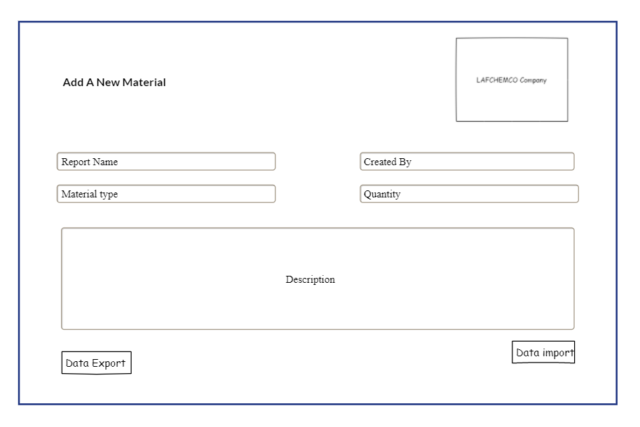

#### b. User case specification:

| Name | Add Material Report |
| --- | --- |
| Created By | trongvvhe172080 |
| Created At | 11/07/2024 |
| Primary Actor | Administrator, Inventory Manager |
| Secondary Actor | None |
| Description | This use case allows the Administrator or Inventory Manager to create a report about importing or exporting material for maintenance purposes. |
| Precondition | PRE-1: The user must be an authenticated Administrator or Inventory Manager. |
| Postcondition | POST-1 The material report is created and stored in the system. |
| Normal Flow | 10.0 Add Material Report  1. The Administrator or Inventory Manager requests to create a material report.  2. The system displays options to select whether the report is for importing or exporting material.  3. The Administrator or Inventory Manager selects the type of report (import or export).  4. The system prompts the user to fill in details such as material type, quantity, source or destination, and reason for import/export.  5. The user fills in all required fields.  6. The system validates the input fields. (see A10.1)  7. The system saves the material report into the system and shows a confirmation dialog. (see E10.1) |
| Alternative Flow | A10.1 Invalid Input Fields  1. The system identifies invalid or missing information in the input fields.  2. The system notifies the Administrator or Inventory Manager about the invalid input.  3. The Administrator or Inventory Manager either corrects the information or cancels the report creation. |
| Exception | E10.1 System Error  1. The system shows an error notification to the user.  2. The system aborts the material report creation process without saving the report.  E10.2 Database Unavailable  1. The system detects that the inventory database is unavailable.  2. The system shows a notification to the user about the unavailability.  3. The system aborts the material report creation process without saving the report.  E10.3 Unauthorized Access Attempt  1. The system detects that the user attempting to create a material report is not authorized.  2. The system logs the unauthorized access attempt.  3. The system shows an error notification and aborts the material report creation process without saving the report. |
| Business Rule | BR-12, BR-30, BR-31 |

### 4.2. View Material Report Details

#### a. Wireframe Screen:

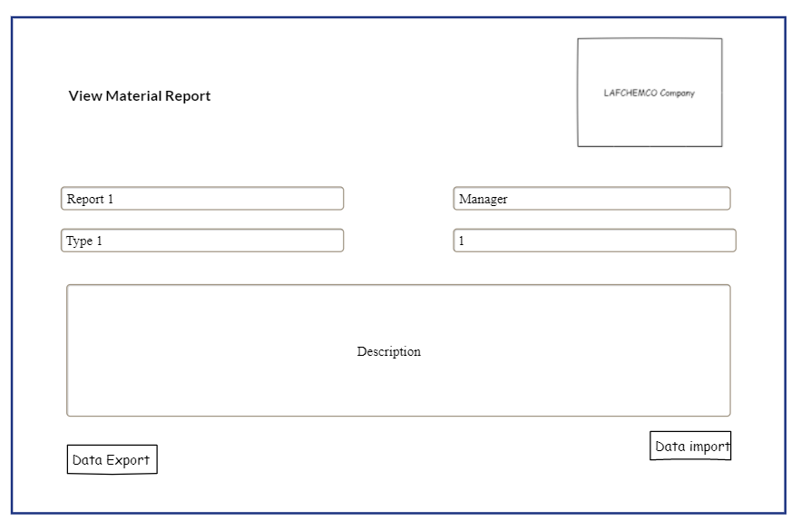

#### b. User case specification:

| Name | View Material Report Details |
| --- | --- |
| Created By | trongvvhe172080 |
| Created At | 11/07/2024 |
| Primary Actor | Administrator, Inventory Manager |
| Secondary Actor | None |
| Description | This use case allows the Administrator or Inventory Manager to select a specified report and view it. |
| Precondition | PRE-1: The user must be an authenticated Administrator or Inventory Manager. |
| Postcondition | POST-1: The specified material report details are displayed to the user. |
| Normal Flow | 11.0 View Material Report Details  1. The Administrator or Inventory Manager requests to view a material report.  2. The system retrieves the list of available material reports from the system.  3. The Administrator or Inventory Manager selects the specified report from the list.  4. The system retrieves the details of the selected report.  5. The system displays the material report details to the Administrator or Inventory Manager. |
| Alternative Flow | A11.1 Update Material Report  1. The Administrator or Inventory Manager decides to update the selected material report.  2. The system displays the form with the current details of the selected report.  3. The Administrator or Inventory Manager updates the necessary fields.  4. The system validates the updated fields. (see A11.2)  5. The system saves the updated report in the system and shows a confirmation dialog. (see E11.1)  A11.2 Invalid Update Fields  1. The system identifies invalid or missing information in the updated fields.  2. The system notifies the Administrator or Inventory Manager about the invalid input.  3. The Administrator or Inventory Manager either corrects the information or cancels the update process. |
| Exception | E11.1 System Error  1. The system shows an error notification to the user.  2. The system aborts the view or update process without making any changes. E11.2 Database Unavailable  1. The system detects that the inventory database is unavailable.  2. The system shows a notification to the user about the unavailability.  3. The system aborts the view or update process without making any changes. E11.3 Unauthorized Access Attempt  1. The system detects that the user attempting to view or update the material report is not authorized.  2. The system logs the unauthorized access attempt.  3. The system shows an error notification and aborts the view or update process without making any changes. |
| Business Rule | BR-12, BR-32, BR-33 |

### 4.3. Delete Material Report

#### a. Wireframe Screen:

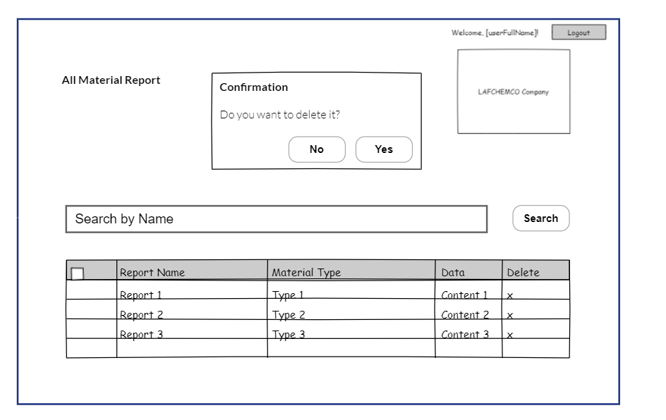

#### b. User case specification:

| Name | Delete Material Report |
| --- | --- |
| Created By | trongvvhe172080 |
| Created At | 11/07/2024 |
| Primary Actor | Administrator, Inventory Manager |
| Secondary Actor | None |
| Description | This use case facilitates the Administrator or Inventory Manager in identifying and permanently removing a specific material report from the system. |
| Precondition | PRE-1: The user must be an authenticated Administrator or Inventory Manager. |
| Postcondition | POST-1 The specified material report is deleted from the system. |
| Normal Flow | 12.0 Delete Material Report  1. The Administrator or Inventory Manager requests to delete a material report.  2. The system retrieves the list of available material reports from the system.  3. The Administrator or Inventory Manager selects the specified report from the list.  4. The system displays the details of the selected report and prompts for confirmation.  5. The Administrator or Inventory Manager confirms the deletion.  6. The system deletes the selected report from the system and shows a confirmation dialog. (see A12.1) |
| Alternative Flow | A12.1 Cancel Deletion  1. The Administrator or Inventory Manager decides to cancel the deletion after viewing the report details.  2. The system aborts the deletion process and returns to the list of material reports. |
| Exception | E12.1 System Error  1. The system shows an error notification to the user.  2. The system aborts the deletion process without making any changes.  E12.2 Database Unavailable  1. The system detects that the inventory database is unavailable.  2. The system shows a notification to the user about the unavailability.  3. The system aborts the deletion process without making any changes.  E12.3 Unauthorized Access Attempt  1. The system detects that the user attempting to delete the material report is not authorized.  2. The system logs the unauthorized access attempt.  3. The system shows an error notification and aborts the deletion process without making any changes. |
| Business Rule | BR-12, BR-34, BR-35, BR-36 |

## 5. Maintenance Plan Management

### 5.1. Add Maintenance Plan

#### a. Wireframe Screen:

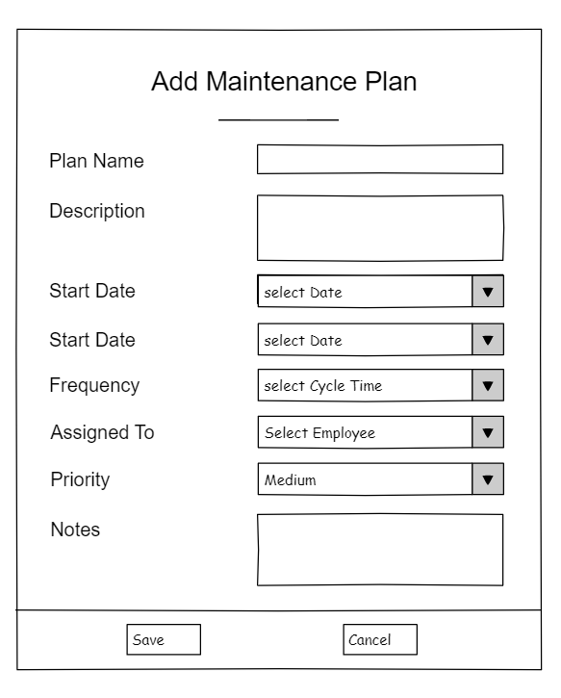

#### b. User case specification:

| Name | Add Maintenance Plan |
| --- | --- |
| Created By | hoangbsthe186345 |
| Created At | 12/07/2024 |
| Primary Actor | Administrator, Maintenance Planning Manager |
| Secondary Actor | Maintenance Operation Manager, Equipment Manager |
| Description | This use case allows the Administrator or Maintenance Planning Manager to create a maintenance plan and assign it to an appropriate Maintenance Operation Manager. |
| Precondition | PRE-1: The user must be an authenticated Administrator or Maintenance Planning Manager. |
| Postcondition | POST-1 The maintenance plan is created and assigned to the selected Maintenance Operation Manager. |
| Normal Flow | 13.0 Add Maintenance Plan  1. The Maintenance Planning Manager (MPM) or Administrator requests to create a new maintenance plan.  2. The system displays a form for creating the maintenance plan, including fields for plan details and assignment options.  3. The MPM or Administrator fills in all required fields, including the details of the maintenance tasks and the selection of the Maintenance Operation Manager (MOM).  4. The system validates the input fields. (see A13.1)  5. The system saves the maintenance plan into the system and shows a confirmation dialog. (see E13.1) |
| Alternative Flow | A13.1 Approving or Rejecting a Request from Equipment Manager  1. The MPM receives a maintenance request from the Equipment Manager.  2. The MPM reviews the request details.  3. The MPM either approves the request and proceeds to create the maintenance plan (return to step 2 of the normal flow) or rejects the request.  4. If the request is rejected, the system notifies the Equipment Manager and logs the rejection reason. |
| Exception | E13.1 System Error  1. The system shows an error notification to the user.  2. The system aborts the maintenance plan creation process without saving the plan.  E13.2 Database Unavailable  1. The system detects that the maintenance plan database is unavailable.  2. The system shows a notification to the user about the unavailability.  3. The system aborts the maintenance plan creation process without saving the plan.  E13.3 Unauthorized Access Attempt  1. The system detects that the user attempting to create a maintenance plan is not authorized.  2. The system logs the unauthorized access attempt.  3. The system shows an error notification and aborts the maintenance plan creation process without saving the plan. |
| Business Rule | BR-12, BR-37, BR-38, BR-39 |

### 5.2. View Maintenance Plan Details

#### a. Wireframe Screen:

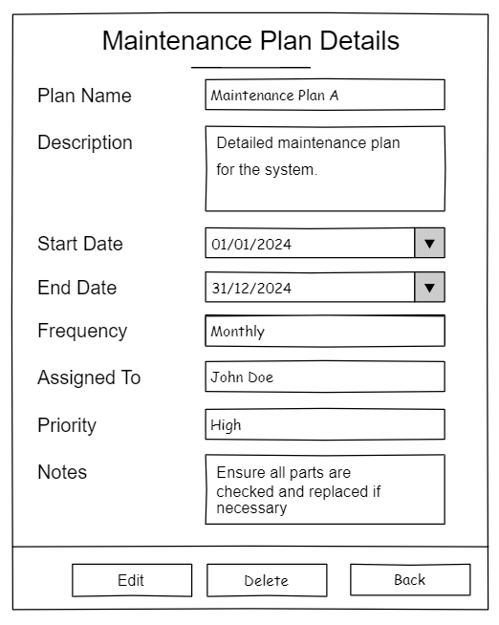

#### b. User case specification:

| Name | View Maintenance Plan Details |
| --- | --- |
| Created By | hoangbsthe186345 |
| Created At | 12/07/2024 |
| Primary Actor | Administrator, Maintenance Planning Manager |
| Secondary Actor | Maintenance Operation Manager |
| Description | This use case allows the Administrator or Maintenance Planning Manager to select a specified maintenance plan and view its details. |
| Precondition | PRE-1: The user must be an authenticated Administrator or Maintenance Planning Manager. |
| Postcondition | POST-1: The specified maintenance plan details are displayed to the user.  POST-2: If any updates are successfully made, all related personnel are informed. |
| Normal Flow | 14.0 View Maintenance Plan Details  1. The Administrator, Maintenance Planning Manager, or Maintenance Operation Manager initiates the request to view maintenance plan details.  2. The system retrieves a list of all available maintenance plans from the system.  3. The Administrator or Maintenance Planning Manager selects the desired maintenance plan from the list.  4. The system fetches and displays comprehensive details of the selected plan, including its tasks and the assigned Maintenance Operation Manager. |
| Alternative Flow | A14.1 Update Maintenance Plan  1. The Administrator or Maintenance Planning Manager decides to update the selected maintenance plan.  2. The system displays the form with the current details of the selected plan.  3. The Administrator or Maintenance Planning Manager updates the necessary fields.  4. The system validates the updated fields. (see A14.2)  5. The system saves the updated plan in the system and shows a confirmation dialog. (see E14.1)  6. The system notifies all related personnel about the updates made to the maintenance plan.  A14.2 Invalid Update Fields  1. The system identifies invalid or missing information in the updated fields.  2. The system notifies the Administrator or Maintenance Planning Manager about the invalid input.  3. The Administrator or Maintenance Planning Manager either corrects the information or cancels the update process. |
| Exception | E14.1 System Error  1. The system shows an error notification to the user.  2. The system aborts the viewing or updating process without making any changes. E14.2 Database Unavailable  1. The system detects that the maintenance plan database is unavailable.  2. The system shows a notification to the user about the unavailability.  3. The system aborts the viewing or updating process without making any changes. E14.3 Unauthorized Access Attempt  1. The system detects that the user attempting to view or update the maintenance plan is not authorized.  2. The system logs the unauthorized access attempt.  3. The system shows an error notification and aborts the viewing or updating process without making any changes. |
| Business Rule | BR-12, BR-40, BR-41, BR-42 |

### 5.3. Delete Maintenance Plan

#### a. Wireframe Screen:

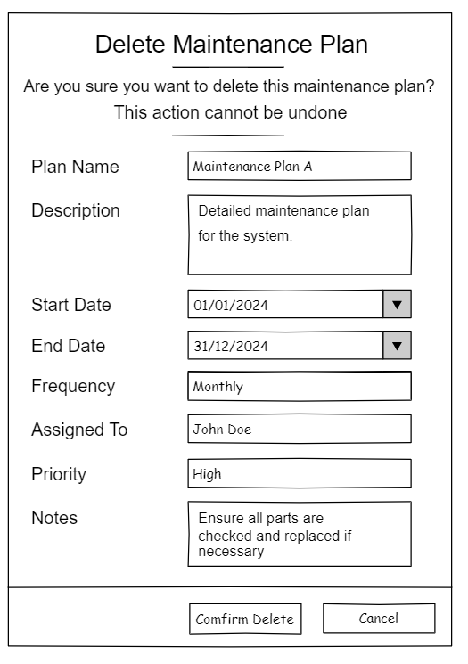

#### b. User case specification:

| Name | Delete Maintenance Plan |
| --- | --- |
| Created By | hoangbsthe186345 |
| Created At | 12/07/2024 |
| Primary Actor | Administrator, Maintenance Planning Manager |
| Secondary Actor | Maintenance Operation Manager |
| Description | This use case allows the Administrator or the Maintenance Planning Manager to select a specified maintenance plan and delete it. |
| Precondition | PRE-1: The user must be an authenticated Administrator or Maintenance Planning Manager. |
| Postcondition | POST-1: The specified maintenance plan is deleted from the system.  POST-2: All related personnel are informed of the deletion of the maintenance plan. |
| Normal Flow | 15.0 Delete Maintenance Plan  1. The Administrator or Maintenance Planning Manager requests to delete a maintenance plan.  2. The system retrieves the list of available maintenance plans from the system.  3. The Administrator or Maintenance Planning Manager selects the specified plan from the list.  4. The system displays the details of the selected plan and prompts for confirmation.  5. The Administrator or Maintenance Planning Manager confirms the deletion.  6. The system deletes the selected plan from the system and shows a confirmation dialog.  7. The system notifies all related personnel about the deletion of the maintenance plan. |
| Alternative Flow | A15.1 Cancel Deletion  1. The Administrator or Maintenance Planning Manager decides to cancel the deletion after viewing the plan details.  2. The system aborts the deletion process and returns to the list of maintenance plans. |
| Exception | E15.1 System Error  1. The system shows an error notification to the user.  2. The system aborts the deletion process without making any changes.  E15.2 Database Unavailable  1. The system detects that the maintenance plan database is unavailable.  2. The system shows a notification to the user about the unavailability.  3. The system aborts the deletion process without making any changes.  E15.3 Unauthorized Access Attempt  1. The system detects that the user attempting to delete the maintenance plan is not authorized.  2. The system logs the unauthorized access attempt.  3. The system shows an error notification and aborts the deletion process without making any changes. |
| Business Rule | BR-12, BR-41, BR-42, BR-43, BR-44 |

## 6. Maintenance Operation Management

### 6.1. Add Maintenance Work

#### 6.1a Wireframe screen: 6.1 Maintenance Operation Manager’s screen

#### 6.1b Use case

| Name | Add Maintenance Work |
| --- | --- |
| Created By | cuongnhhe186494 |
| Created At | 13/07/2024 |
| Primary Actor | Administrator, Maintenance Operation Manager |
| Secondary Actor | Maintenance Operator |
| Description | This use case allows the Administrator or the Maintenance Operation Manager to create a detailed maintenance work plan based on an existing maintenance plan and assign specific tasks to the appropriate Maintenance Operators. |
| Precondition | PRE-1: The user must be an authenticated Administrator or Maintenance Operation Manager. |
| Postcondition | POST-1: A detailed maintenance work plan is created and saved in the system.  POST-2: Maintenance Operators are assigned to specific tasks within the maintenance work plan.  POST-3: All related personnel are informed of the creation and assignments of the maintenance work plan. |
| Normal Flow | 16.0 Add Maintenance Work  1. The Administrator or Maintenance Operation Manager requests to create a new maintenance work plan.  2. The system retrieves the list of existing maintenance plans from the system.  3. The Administrator or Maintenance Operation Manager selects the assigned maintenance plan to base the work plan on.  4. The system displays a form for creating the detailed maintenance work plan, including fields for task details and assignment options.  5. The Administrator or Maintenance Operation Manager fills in all required fields, including the details of the tasks and the selection of the Maintenance Operators. 6. The system validates the input fields. (see A16.1)  7. The system saves the maintenance work plan into the system and shows a confirmation dialog.  8. The system notifies all related personnel about the creation and assignments of the maintenance work plan. |
| Alternative Flow | A16.1 Invalid Fields  1. The system identifies invalid or missing information in the input fields.  2. The system notifies the Administrator or Maintenance Operation Manager about the invalid input.  3. The Administrator or Maintenance Operation Manager either corrects the information or cancels the creation process. |
| Exception | E16.1 System Error  1. The system shows an error notification to the user.  2. The system aborts the creation process without saving the maintenance work plan.  E16.2 Database Unavailable  1. The system detects that the maintenance plan database is unavailable.  2. The system shows a notification to the user about the unavailability.  3. The system aborts the creation process without saving the maintenance work plan.  E16.3 Unauthorized Access Attempt  1. The system detects that the user attempting to create the maintenance work plan is not authorized.  2. The system logs the unauthorized access attempt.  3. The system shows an error notification and aborts the creation process without saving the maintenance work plan. |
| Business Rule | BR-12, BR-42, BR-45, BR-46, BR-47 |

### 6.2. View Maintenance Work Details

#### 6.2a. Wireframe screen

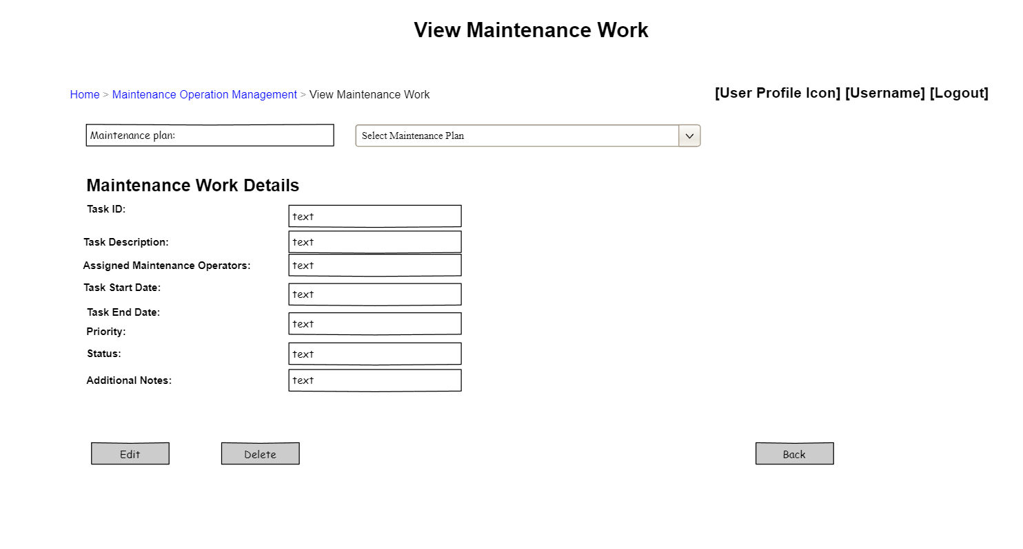  
*6.2* Maintenance Operation Manager’s screen  
  
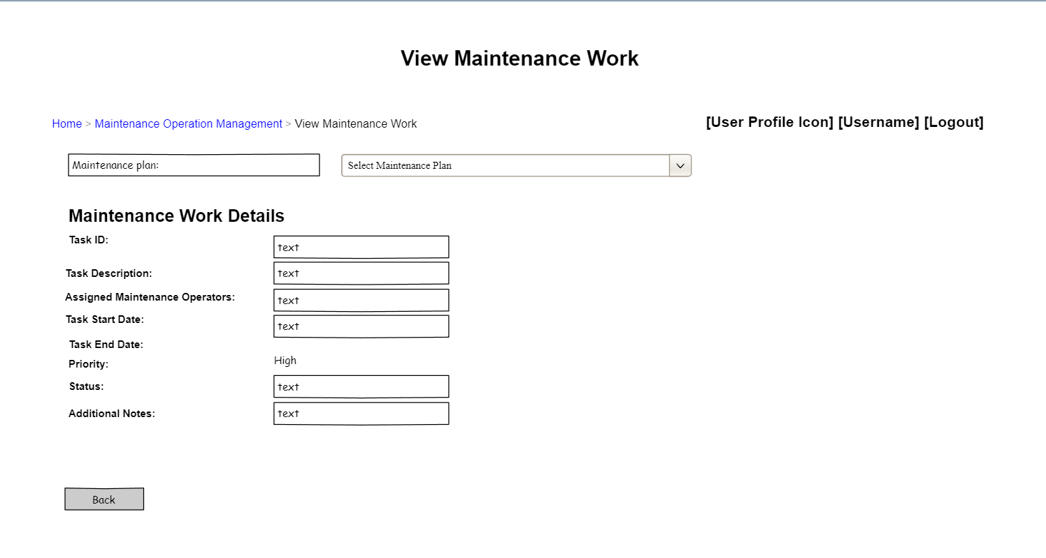

*6.2* Maintenance employee’s screen

#### 6.2b. View Maintenance Work use case:

| Name | View Maintenance Work Details |
| --- | --- |
| Created By | cuongnhhe186494 |
| Created At | 13/07/2024 |
| Primary Actor | Administrator, Maintenance Operation Manager |
| Secondary Actor | Maintenance Operator |
| Description | This use case allows the Administrator or Maintenance Operation Manager to view the details of maintenance work assigned to Maintenance Operators within a specified work plan. |
| Precondition | PRE-1: The user must be an authenticated Administrator or Maintenance Operation Manager. |
| Postcondition | POST-1 The details of the specified maintenance work plan are displayed to the user. |
| Normal Flow | 17.0 View Maintenance Work Details  1. The Administrator or Maintenance Operation Manager requests to view maintenance work details.  2. The system retrieves the list of available maintenance work plans from the system.  3. The Administrator or Maintenance Operation Manager selects the specified work plan from the list.  4. The system displays the details of the selected work plan, including assigned tasks and Maintenance Operators. |
| Alternative Flow | A17.1 Update Maintenance Work  1. The Administrator or Maintenance Operation Manager decides to update the assignment of tasks within the selected work plan.  2. The system displays the current assignments and allows the Administrator or Maintenance Operation Manager to reassign tasks among Maintenance Operators.  3. The Administrator or Maintenance Operation Manager makes the necessary updates to task assignments.  4. The system validates the updated assignments. (see A17.2)  5. The system saves the updated work plan in the system and shows a confirmation dialog. (see E17.1)  A17.2 Invalid Task Assignments  1. The system identifies invalid or conflicting task assignments.  2. The system notifies the Administrator or Maintenance Operation Manager about the issues with task assignments.  3. The Administrator or Maintenance Operation Manager adjusts the assignments to resolve the issues. |
| Exception | E17.1 System Error  1. The system shows an error notification to the user.  2. The system aborts the viewing or updating process without making any changes. E17.2 Database Unavailable  1. The system detects that the maintenance plan database is unavailable.  2. The system shows a notification to the user about the unavailability.  3. The system aborts the viewing or updating process without making any changes. E17.3 Unauthorized Access Attempt  1. The system detects that the user attempting to view or update the maintenance work details is not authorized.  2. The system logs the unauthorized access attempt.  3. The system shows an error notification and aborts the viewing or updating process without making any changes. |
| Business Rule | BR-12, BR-48, BR-49 |

### 6.3. Delete Maintenance Work

#### 6.3a.Wireframe screen:



6.3 Delete maintenance work

#### 6.3b.Delete maintenance work usecase:

| Name | Delete Maintenance Work |
| --- | --- |
| Created By | cuongnhhe186494 |
| Created At | 13/07/2024 |
| Primary Actor | Administrator, Maintenance Operation Manager |
| Secondary Actor | Maintenance Operator |
| Description | This use case allows the Administrator or Maintenance Operation Manager to delete a specified task assignment from a maintenance work plan assigned to a Maintenance Operator. |
| Precondition | PRE-1: The user must be an authenticated Administrator or Maintenance Operation Manager. |
| Postcondition | POST-1: The specified task assignment is deleted from the maintenance work plan.  POST-2: All related personnel are informed of the deletion of the task assignment. |
| Normal Flow | 18.0 Delete Maintenance Work  1. The Administrator or Maintenance Operation Manager requests to view a task assignment from a maintenance work plan.  2. The system retrieves the list of available maintenance work plans from the system.  3. The Administrator or Maintenance Operation Manager selects the specified work plan from the list.  4. The system displays the details of the selected work plan, including assigned tasks to Maintenance Operators.  5. The Administrator or Maintenance Operation Manager selects the task assignment to delete and confirms the action.  6. The system deletes the selected task assignment from the maintenance work plan and shows a confirmation dialog.  7. The system notifies all related personnel about the deletion of the task assignment. |
| Alternative Flow | A18.1 Cancel Deletion  1. The Administrator or Maintenance Operation Manager decides to cancel the deletion after selecting the task assignment.  2. The system aborts the deletion process and returns to the details of the maintenance work plan. |
| Exception | E18.1 System Error  1. The system shows an error notification to the user.  2. The system aborts the deletion process without making any changes.  E18.2 Database Unavailable  1. The system detects that the maintenance plan database is unavailable.  2. The system shows a notification to the user about the unavailability.  3. The system aborts the deletion process without making any changes.  E18.3 Unauthorized Access Attempt  1. The system detects that the user attempting to delete the task assignment is not authorized.  2. The system logs the unauthorized access attempt.  3. The system shows an error notification and aborts the deletion process without making any changes. |
| Business Rule | BR-12, BR-42, BR-50, BR-51, BR-52 |

## 7. Accounting Management

### 7.1 Approve Disbursement Request

#### a. Wireframe Screen:

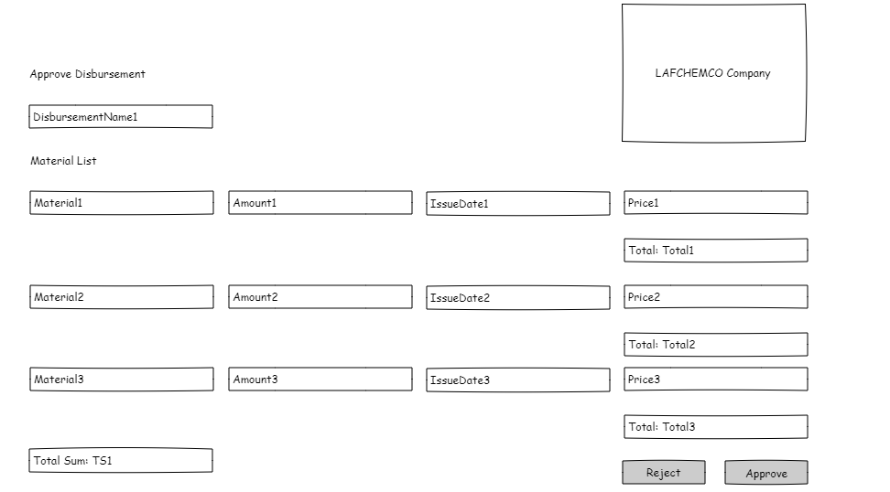

#### b. Use Case Specification:

| Name | Approve Disbursement Request |
| --- | --- |
| Created By | phuongndhe186453 |
| Created At | 14/07/2024 |
| Primary Actor | Administrator, Accounting Manager |
| Secondary Actor | Inventory Manager |
| Description | This use case allows the Administrator or the Accounting Manager to either approve or reject a disbursement request made by an Inventory Manager. |
| Precondition | PRE-1: The user must be an authenticated Administrator or Accounting Manager.  PRE-2: The disbursement request must exist in the system.  PRE-3: The Inventory Manager must have submitted the disbursement request. |
| Postcondition | POST-1: The disbursement request is either approved or rejected, and the decision is logged in the system.  POST-2: The Inventory Manager is notified of the decision. |
| Normal Flow | 19.0 Approve Disbursement Request  1. The Administrator or Accounting Manager accesses the pending disbursement requests.  2. The system displays the list of disbursement requests.  3. The Administrator or Accounting Manager selects a disbursement request to review.  4. The system retrieves and displays the details of the selected disbursement request.  5. The Administrator or Accounting Manager reviews the details and clicks on the "Approve" button. (see A19.1)  6. The system validates the approval action.  7. The system marks the disbursement request as approved and logs the action.  8. The system notifies the Inventory Manager of the approval decision. |
| Alternative Flow | A19.1 Reject Disbursement Request  1. The Administrator or Accounting Manager reviews the details of the disbursement request.  2. The Administrator or Accounting Manager clicks on the "Reject" button.  3. The system prompts for a reason for rejection.  4. The Administrator or Accounting Manager provides the reason and confirms the rejection.  5. The system validates the rejection action.  6. The system marks the disbursement request as rejected, logs the action, and stores the reason for rejection.  7. The system notifies the Inventory Manager of the rejection decision along with the reason. |
| Exception | E19.1 System Error  1. The system shows an error notification to the user.  2. The system aborts the approval/rejection process without saving any changes. E19.2 Unauthorized Access Attempt  1. The system detects that the user attempting to approve or reject the disbursement request is not authorized.  2. The system logs the unauthorized access attempt.  3. The system shows an error notification and aborts the approval/rejection process.  E19.3 Invalid Disbursement Request  1. The system detects that the disbursement request is invalid or has already been processed.  2. The system shows a notification to the user about the invalid request.  3. The system aborts the approval/rejection process without saving any changes. |
| Business Rule | BR-12, BR-42, BR-53, BR-54, BR-55 |

### 7.2 View Disbursement Request Details

#### a. Wireframe Screen:

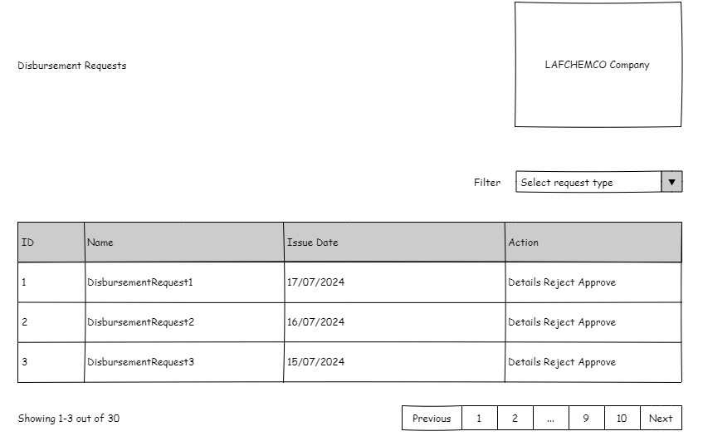

#### b. Use Case Specification:

| Name | View Disbursement Request Details |
| --- | --- |
| Created By | phuongndhe186453 |
| Created At | 13/07/2024 |
| Primary Actor | Administrator, Accounting Manager |
| Secondary Actor | None |
| Description | This use case allows the Administrator or the Accounting Manager to select a certain disbursement request and see its details. |
| Precondition | PRE-1: The user must be an authenticated Administrator or Accounting Manager.  PRE-2: The disbursement request must exist in the system. |
| Postcondition | POST-1: The details of the selected disbursement request are displayed to the user. |
| Normal Flow | 20.0 View Disbursement Request Details  1. The Administrator or Accounting Manager accesses the list of disbursement requests.  2. The system displays the list of disbursement requests.  3. The Administrator or Accounting Manager selects a specific disbursement request.  4. The system retrieves and displays the details of the selected disbursement request. |
| Alternative Flow | None |
| Exception | E20.1 System Error  1. The system shows an error notification to the user.  2. The system aborts the process without displaying any details.  E20.2 Unauthorized Access Attempt  1. The system detects that the user attempting to view the disbursement request details is not authorized.  2. The system logs the unauthorized access attempt.  3. The system shows an error notification and aborts the process. |
| Business Rule | BR-55, BR-56 |

# IV. Non-Functional Requirements

## 1. External Interfaces

### 1.1. User Interfaces

* **UI-1**: Each screen in the LAFCHEMCO System shall include a help link to provide guidance on using that specific functionality.
* **UI-2**: The system shall support complete navigation and data entry using keyboard inputs alone, in addition to mouse and keyboard combinations.

### 1.2. Software Interfaces

* **SI-1**: Equipment Inventory System
  + **SI-1.1**: The LAFCHEMCO System shall transmit maintenance requests and updates to the Equipment Inventory System through a RESTful API.
  + **SI-1.2**: The LAFCHEMCO System shall retrieve equipment availability status and maintenance history from the Equipment Inventory System.
  + **SI-1.3**: Upon receiving notification from the Equipment Inventory System about equipment unavailability, the LAFCHEMCO System shall update the maintenance schedule accordingly.
* **SI-2**: Maintenance Planning System
  + **SI-2.1**: The LAFCHEMCO System shall integrate with the Maintenance Planning System to receive approved maintenance plans and schedules.
  + **SI-2.2**: It shall provide status updates and completion reports to the Maintenance Planning System after executing scheduled maintenance tasks.

### 1.3. Hardware Interfaces

* No hardware interfaces have been identified for the LAFCHEMCO System.

### 1.4. Communications Interfaces

* **CI-1**: The LAFCHEMCO System shall send email notifications to relevant personnel upon initiation, completion, or changes to scheduled maintenance tasks.
* **CI-2**: It shall communicate via SMS notifications to notify maintenance operators and managers about urgent maintenance requests or updates.

## 2. Quality Attributes

### 2.1. Usability Requirements

* **USE-1**: The LAFCHEMCO System shall allow maintenance personnel to retrieve the maintenance history of equipment with a single interaction.
* **USE-2**: 95% of new users shall be able to successfully create and assign maintenance tasks without errors on their first attempt.

### 2.2. Performance Requirements

* **PER-1**: The system shall accommodate a total of 200 users and a maximum of 50 concurrent users during peak usage times, with an estimated average session duration of 10 minutes.
* **PER-2**: 95% of webpages generated by the LAFCHEMCO System shall download completely within 3 seconds from the time the user requests the page over a 50Mbps or faster Internet connection.
* **PER-3**: The system shall display confirmation messages to users within an average of 2 seconds and a maximum of 4 seconds after the user submits information to the system.

### 2.3. Security Requirements

* **SEC-1**: All network transactions that involve sensitive maintenance data or personally identifiable information shall be encrypted per company security policy.
* **SEC-2**: Users shall be required to authenticate using their company credentials for all operations within the LAFCHEMCO System.
* **SEC-3**: Only authorized Maintenance Managers shall be permitted to create, modify, or approve maintenance plans, per company policy.
* **SEC-4**: The system shall restrict access so that Maintenance Operators can only view maintenance tasks assigned to them.

### 2.4. Safety Requirements

* **SAF-1**: The system shall provide visibility into safety protocols associated with maintenance tasks, highlighting any hazardous materials or procedures that may pose risks to personnel.

### 2.5. Availability Requirements

* **AVL-1**: The LAFCHEMCO System shall be available at least 99% of the time between 6:00 A.M. and 10:00 P.M. local time and at least 95% of the time between 10:00 P.M. and 6:00 A.M. local time, excluding scheduled maintenance windows.

### 2.6. Robustness Requirements

* **ROB-1**: If the connection between the user and the LAFCHEMCO System is interrupted before a new maintenance task is either confirmed or terminated, the LAFCHEMCO System shall enable the user to recover the incomplete task and continue working on it.

# V. Data Dictionary